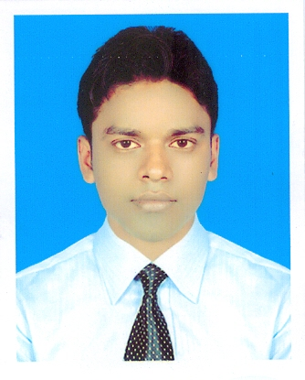
Curriculum Vitae

MD. AKTER HOSSAIN
371 DIT Road, West Rampura, Dhaka.
Contact: +8801701312840
E-mail: mdaktersabus.96@gmail.com

Career objective:
To achieve career excellence through dedication of honesty, sincerity, and hard work as corporate executive. Where I can reflect my academic knowledge and has an opportunity to maximize the potentiality. Look forward to working environment which will provide me the opportunity to develop myself.
Educational Qualification:
Examination/Degree | Institution | Group/Department | Passing Year | GPA/Division
M.B.A. | Southeast University, Dhaka. | Finance (Major) | 2016 | 3.30 (Out of 4)
B.B.S. | Govt. Titumir College, Dhaka. | Business Studies | 2014 | 2nd Class
H.S.C | Amrito Lal Dey College, Barisal. | Business Studies | 2008 | 4.30 (Out of 5)
S.S.C. | Borakota Union Secondary School, Barisal. | Business Studies | 2006 | 4.44 (Out of 5)

Professional Experience:

- Organization: Top Ranked, Bangladesh Honda Private Ltd.

Designation: Service Manager & Store In charge

Period: From 15.01.2018 to still now

- Company: Pran Agro Food Ltd. (Distribution House of Hazi Enterprise)
Designation: Sales Representative
Period: 25/2/2015 – 28/4/2016
Address: Konabari, Gazipur, Dhaka.

Personal Information:
Name: Md. Akter Hossain
Father’s Name: Md. Alamgir Hossain
Mother’s Name: Rozina Begum
Date of Birth: 05, May, 1990
Marital Status: Unmarried
Nationality: Bangladeshi (By birth)
Blood Group: B+
Religion: Islam
Present Address: Wirelessgate, Mohakhali, Dhaka- 1212.
Permanent Address: Village: Gazirper, Post: Gazirper, Upazilla: Ujirpur, Zilla: Barisal.
Current Location: Dhaka
NID No.: 19900619421000413
Contact No.: +8801926159498
E-mail Address: mdaktersabus.96@gmail.com
Language Proficiency:
I have excellent communication skill in mother tongue Bengali and reasonable command both in spoken and written English.
Computer Literacy:
Reasonable access in Microsoft Word, Power point and Microsoft Excel with windows based platform. Familiar with internet browsing & e-mail.

Extra Curriculum Activities:
1. Worked as an Intern in Bank Asia Ltd. at Shantinagar Branch with the duration of 3 months from 24/07/2016 to 24/10/2016.
2. Research on various social phenomenon’s as an academic part.
Interests:
Reading novel and story, traveling, watching movies and enjoying music with the help of its lyric.
Strengths:
Hard working, maintain good relation with others, self motivated, enthusiastic & punctual, dynamic & creative in thinking, sense of good organizational behavior.

References:
Md. Mahabubur Rahman
Deputy Secretary Legislative and Parliamentary Affairs
Division Ministry of Law, Justice and Parliamentary Affairs
Contract: 01711588307, Tel: 88-02-9570063
Email: mahabub375@yahoo.com

I certify that all information stated in these curriculum vitae is true and complete to the best of my knowledge and that I authorize the recipient to verify the information provided.

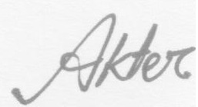
…………………………
Md.Akter Hossain

